# Table 4.1

|  |  |  |  |  |  |  |  |  |  |  |  |  |  |  |  |  |  |  |  |  |  |  |  |  |  |
| --- | --- | --- | --- | --- | --- | --- | --- | --- | --- | --- | --- | --- | --- | --- | --- | --- | --- | --- | --- | --- | --- | --- | --- | --- | --- |
| 25 Seeds-Group E Concentration Control Seeds 25  Date Began Testing: January/21/2002 | | | | | | | | | | | | | | | | | | | | | | | | | |
| Dish | E-1 | | | | | E-2 | | | | | E-3 | | | | | E-4 | | | | | E-5 | | | | |
| Day | 5 | 7 | 9 | 11 | 13 | 5 | 7 | 9 | 11 | 13 | 5 | 7 | 9 | 11 | 13 | 5 | 7 | 9 | 11 | 13 | 5 | 7 | 9 | 11 | 13 |
| CL |  |  |  |  |  |  |  |  |  |  |  |  |  |  |  |  |  |  |  |  |  |  |  |  |  |
| AH | 3.9 | 4.2 | 4.6 | 5.0 | 5.5 | 3.6 | 3.9 | 4.2 | 5.1 | 5.2 | 3.9 | 4.1 | 4.2 | 5.7 | 6 | 3.7 | 3.9 | 4.1 | 4.3 | 4.5 | 3.8 | 3.9 | 4.1 | 4.2 | 4.3 |
| RL | 2.1 | 2.2 | 2.9 | ↑ | ↑ | 2.3 | 2.5 | 2.8 | ↑ | ↑ | 1.9 | 2.5 | ↑ | ↑ | ↑ | x | 1.5 | 1.9 | 2.5 | 2.8 | 2.1 | 2.3 | ↑ | ↑ | ↑ |

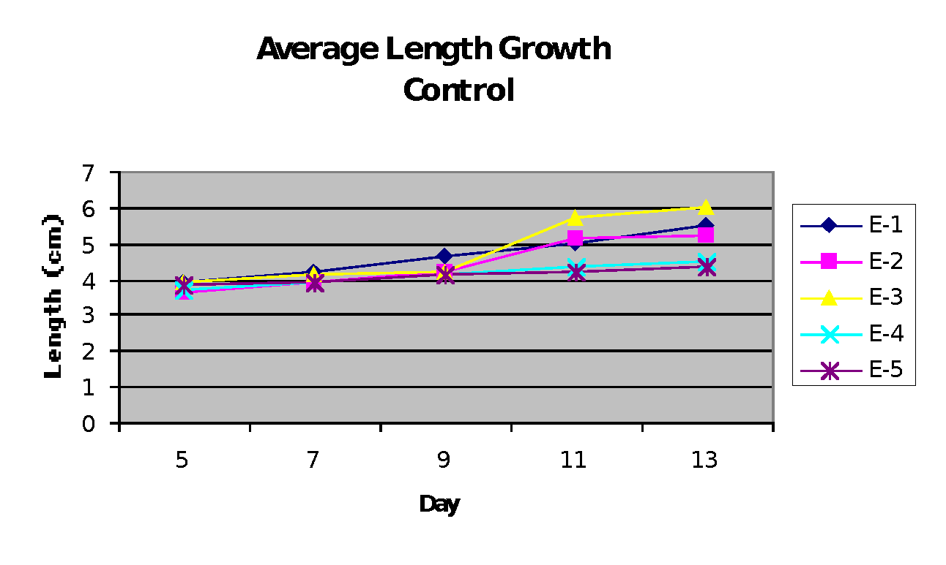**Figure 4.3**